October 8th, 2006
Hi
As a template for this letter, I used the letter for October 8th, 2000. Interesting reading it before deleting it to make way for this letter. Three of its highlights:
- The Olympic Games in Sydney had just finished.
- Got a letter from Gavin who was in Tunisia on float.
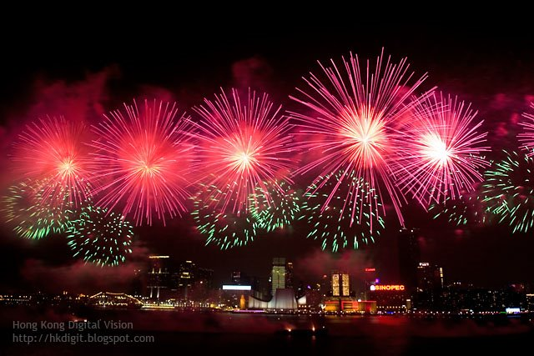
- President Miloslovic of Serbia had been overthrown.
Back to the present. Last Sunday, October 1st, was National day. Fireworks (waste of money) display in evening – think I said this last week. Anyway, for other nice pictures, go to this website:
http://hkdigit.blogspot.com/

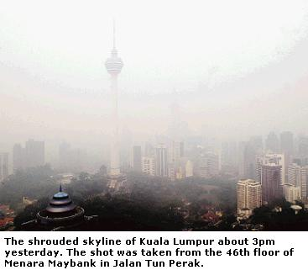
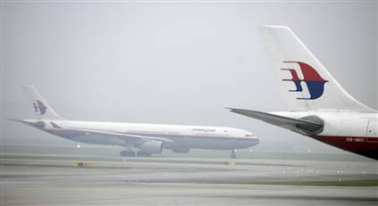
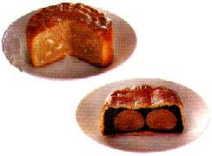
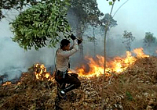
On Friday evening, the hotel held its annual mid-autumn poolside buffet. Very good this year with little additions that improved it. The food was about the same (though I didn’t eat any of the moon cakes). But this year they had lots more seating so that everybody could get a seat without having to stand or sit on ledges. I was sitting at a table with a family from Sacramento; the father is on a 3-year contract piloting chartered executive jets. The hotel had placed lamps in the main pool and had also drained the children’s pool and placed in it toy houses for children to play in and had set up chess and Chinese chess for people to play. The mid-autumn moon is supposed to be the roundest and brightest at this time and it could just be seen through the thick blanket of air pollution!
Talking about air pollution, it is that time of the year when farmers in Indonesian Borneo burn off large tracts of land producing smoke that blankets neighbouring countries including Brunei, Singapore and Malaysia. The smoke was very thick and forced some airlines to stop flying.
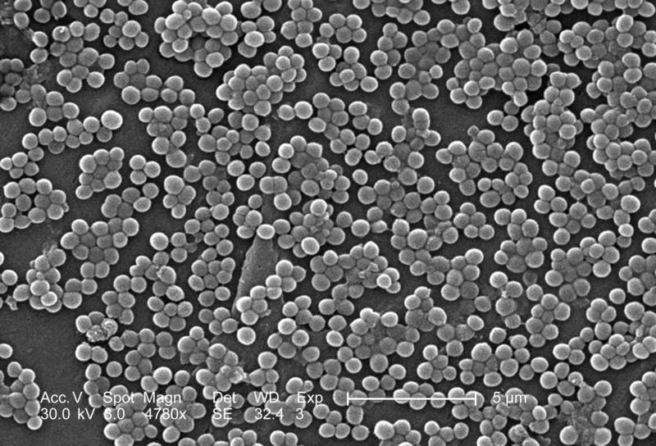
It was reported during the week that the MRSA (Methicillin-resistant Staphylococcus aureus) bacterium has been detected in the HK community and not just in hospitals. That’s not particularly good news. On Friday, I went to the Tuen Mun clinic but only got the stitches removed from the biopsies on my back 10 days ago. There was no doctor's report which means another half day will be wasted just to go and get that. They wanted me to go on Monday but I said ‘No’ and would come at the end of October.
Electron micrograph of MRSA
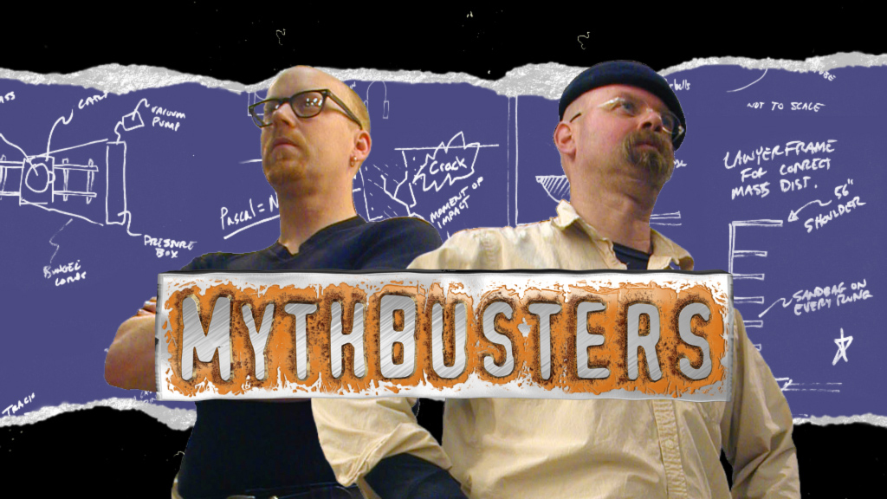
On TV there is an interesting US TV programme called ‘Mythbusters.’ Have you heard of it? They investigate widely-held myths/beliefs/old-wives tales and other odd things to see if they are true or not. In the last programme, they investigated the Mr Bean skit in which he exploded dynamite in a bucket of paint to paint a room (which included the silhouette of a man who had gone back into the room to collect his hat when the explosion occurred). Have you seen that Mr Bean show? Anyway, the mythbusters showed that it could not actually be done.
No swimming this past week of course. Did a 30 minute rowing on one day with an improved time over the last row about three weeks ago.
In yesterday’s SCMP, there was an article on a UN crime survey which showed that only Cambodia beats HK for consumer fraud! Cambodia had 34% of people who were victims with HK second at 21.7% compared, for example, with the US (11.4%), Japan (2%) and an average of all the countries surveyed (7.7%). There does tend to be a lot of dishonesty and rip offs in too many HK shops. However, the survey also showed that HK is one of the safest cities in the world when it comes to violent crime.

That’s about it for this time.
Cheers

